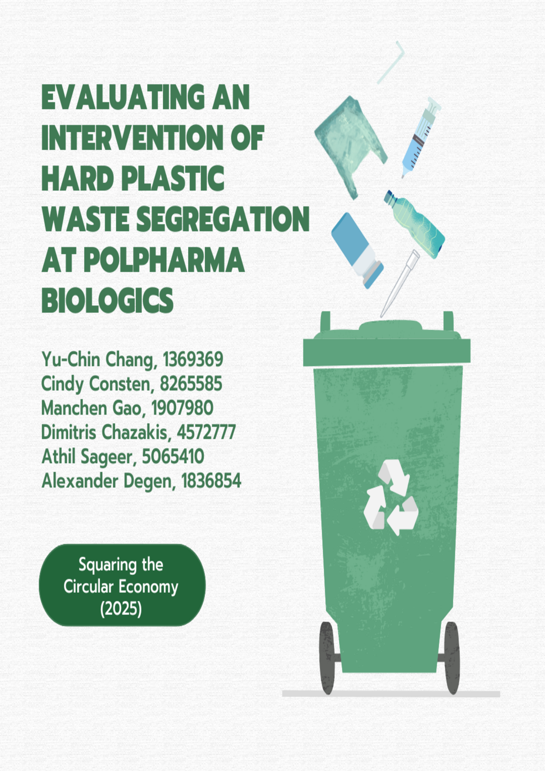
Table of Contents

List of Tables 3
List of Figures 3
Abbreviations 3
Abstract 4
1. Introduction 5
2. Theoretical Approach 7
3. Problem Definition and Research Questions 9
4. Methodology 10
4.1. Case study selection and Data Collection 11
4.2. Analytical Framework 12
4.2.1. CBA 12
4.2.2. Assumptions made for CBA 13
4.2.3. Environmental Evaluation 13
5. Results 15
5.1. Interview PreZero 15
5.2. Interview Polpharma Biologics 15
5.3. CBA Results - BAU and Alternative Scenario 16
5.4. CBA result - Environmental Benefit CO₂ 18
6. Discussion 20
6.1. Cost Savings and Financial Considerations 20
6.2. Environmental Benefits 20
7. Conclusion and Recommendations 22
8. References 23
9. Appendix 25
Appendix A: GMO Waste Disposal Costs in PB laboratory 25
Appendix B: Data related to hard plastic in general waste bin in a laboratory in PB 26
Appendix C: Net cost benefit 27
Appendix D-1: Transcript of the Interview with PreZero 28
Appendix D-2: Transcript of the Interview with Polpharma Biologics (1) 29
Appendix D-3: Transcript of the Interview with Polpharma Biologics (2) 32

Word count: 5494 words (excluding table of contents, abstract and appendices)
List of Tables

Table 1. Tested Scenarios 10
Table 2. Weight of two main types of total hard plastics (Hannay, 2002) 18
Table 3. Environmental benefits of recycling polypropylene (PP) and polystyrene (PS) compared to fossil-based production 19

List of Figures
Figure 1. Analytical Framework 10
Figure 2. Different types of waste in Polpharma Biologics labs 13
Figure 3. Average CO₂ numbers for recycled and fossil plastics in The Netherlands, in kg CO₂-eq. per kg plastic (Delft, C. E., 2023). 14
Figure 4. Comparison of Annual Costs Under BAU and Alternative Scenarios (Including GMO and Hard Plastic (HP)) 17
Figure 5. Comparison of Annual Weights Under BAU and Alternative Scenarios (Including GMO and Hard Plastic) 18

Abbreviations
Business As Usual (BAU)
Biosafety Level (BSL)
Carbon Dioxide (CO₂)
Carbon Dioxide Equivalent (CO₂-eq.)
Cost-Benefit Analysis (CBA)
Environmental Benefits (EB)
Environmental Evaluation (EE)
Genetically Modified Organism (GMO)
Hard Plastic (HP)
Minimal Risk Level 1 (ML-1)
Moderate Risk Level 2 (ML-2)
Polyethylene (PE)
Polypropylene (PP)
Polystyrene (PS)
Polpharma Biologics (PB)
Stichting Incubator Utrecht (SIU)

Abstract
Hard plastic segregation is a waste flow management process that promotes sustainability and can lead to fruitful financial and environmental outcomes. This report investigates these implications in the pharmaceutical company Polpharma Biologics (PB), a resident of Stichting Incubator Utrecht (SIU). Focusing on PB’s operations as a case study within a laboratory setting, interviews for data collection, cost-benefit analysis (CBA) and Environmental Evaluation (EE) are applied as methodologies to assess current practices and identify potential improvements. The results reveal that implementing an intervention involving a separate waste stream for hard plastics could substantially increase financial savings and enhance environmental benefits through reduced CO₂ emissions. Despite such potential benefits, challenges like regulatory restrictions and legislation related to contaminated waste risks remain prevalent, highlighting the complexities associated with effective waste management in a laboratory environment. Future steps for refining this intervention should include expanding data availability, improving employee behaviour and conducting a comprehensive review of laboratory regulations. These steps would be necessary to benchmark PB’s sustainability footprint.

Keywords: waste management, hard plastic segregation, cost-benefit analysis, sustainability.
Word count: 5494 words (excluding table of content, abstract and appendices)

Introduction
The Stichting Incubator Utrecht (SIU), (SIU, 2024) operates two cutting-edge business incubators, the Alexander Numan Building and the Life Science Incubator, located at Utrecht Science Park. Its primary objective is to facilitate the development of innovative biotechnology startups. Furthermore, it offers affordable laboratory and office spaces, encourages collaboration among entrepreneurs, and provides an integrated package of services, including coaching, networking, and business development support.

The startup companies hosted at SIU primarily focus on biotechnology, pharmaceuticals, and medical technology. A considerable number of these companies are engaged in the development of advanced therapeutics and diagnostics, employing state-of-the-art technologies. For example, HUB Organoids, Lava Therapeutics, Laigo Bio, and Gyes are engaged in the development of novel solutions in organoid technology, T-cell therapies, and antibody platforms for the treatment of diseases such as cancer and autoimmune disorders. Similarly, AMT Medical and GenDx are engaged in the development of medical devices and diagnostics aimed at improving patient care. Their products include innovative heart bypass systems and high-resolution molecular diagnostic tests. Moreover, companies such as Polpharma Biologics, Solvias, and U-CyTech Biosciences provide pharmaceutical products and research services, thereby supporting drug development and laboratory needs. Venture capital and academic institutions, including Thuja Capital and UMC Medische Fysiologie, contribute to the ecosystem by providing financial support to early-stage ventures and conducting fundamental research in cardiac physiology. Collectively, these companies exemplify SIU's mission of fostering innovation, sustainability, and collaboration across multiple disciplines in healthcare and biotechnology.

PreZero is SIU's main waste disposal partner. It is an innovative environmental service provider that establishes a comprehensive, closed-loop material flow through the integration of sustainability and resource conservation into each stage of waste management. From the collection and sorting of post-consumer and industrial waste to the recycling and manufacturing of high-quality recyclable materials, the company ensures the reuse of materials in the market, thereby conserving resources and maximizing value. Additionally, PreZero can provide solutions tailored to specific needs, including waste disposal, packaging licensing, and zero-waste consulting, which facilitate the transition from traditional linear waste disposal methods to sustainable alternatives.

However, SIU is currently facing considerable challenges in the management of plastic waste generated by its subsidiary laboratories and offices. The high-tech laboratories, which require strict contamination controls, rely heavily on virgin plastics, rendering the use of recycled plastics impractical in many cases. Furthermore, plastic packaging materials constitute a significant proportion of the waste produced. Adding to these issues is the contamination of some plastics with toxic, bio-hazardous, or genetically modified organism (GMO) materials, which necessitates the use of specialised disposal methods.

The lack of an effective plastic waste segregation system increases economic inefficiencies and hinders the potential for waste circularity. Therefore, the optimization of waste management practices requires the development of solutions that balance economic feasibility with environmental sustainability, while also reducing the time costs associated with laboratory and office operations.

The SIU is currently experiencing additional challenges. Firstly, it is essential to gain an understanding of the current waste management practices at SIU. This will entail identifying the existing waste streams, determining which of these are separated, and quantifying the amount of plastic waste categorised as general or commercial waste. Meanwhile, it is crucial to analyze the financial implications of managing these streams, including how better waste management affects costs and benefits. This is also one of the focuses of this study.

Additionally, it is important to consider the potential contamination of plastic materials, particularly in laboratory settings. The handling of plastics exposed to hazardous substances must adhere to specialised protocols to ensure compliance with rigorous safety and environmental standards. Thus, it is essential to clearly define the categories of waste streams, including unused products, non-separable waste designated for incineration, and recyclable waste. Among these, non-contaminated plastics have significant recycling potential. By reusing these materials as resources through proper sorting and recycling processes, it is possible to reduce the environmental impact to a significant extent.

Theoretical Approach
In the Netherlands, laboratory waste management is governed by stringent regulations to ensure environmental safety and public health. The Environmental Management Act serves as the foundational legal framework, outlining requirements for the storage, transport, and processing of hazardous chemical substances. Complementing this, the Regulations for Reporting Industrial Waste and Hazardous Waste mandate proper registration, packaging, and handling of chemical waste. Specific safety measures, such as using approved waste containers, accurate labelling, and disposing of contaminated personal protective equipment, are enforced to manage hazardous waste effectively. Compliance with these regulations is essential to avoid sanctions and ensure the safe disposal of laboratory waste (Chemical Waste Netherlands, n.d.).

The Dutch regulatory framework for GMO in laboratories is characterised by stringent legislation. The containment levels for GMO activities are classified into different categories, primarily Biosafety Level (BSL)-1 to BSL-4, which are referred to as ML-I to ML-IV in the Netherlands, each with specific requirements and protocols (Kimman, Smit, & Klein, 2008). This research involved Minimal Risk Level 1 (ML-1) and Moderate Risk Level 2 (ML-2) laboratories. ML-1 laboratories are utilised for the manipulation of GMO that present minimal to no risk to humans or the environment. These include non-pathogenic genetically modified bacteria or plants, for which standard containment measures are sufficient. ML-2 laboratories are necessary for GMOs that pose a moderate risk, such as genetically modified microorganisms with potential pathogenic traits or resistance genes, requiring enhanced containment protocols. According to Dutch regulations, a Class II biosafety cabinet is not merely an option as in other countries, but rather a mandatory requirement at the ML-2.

The National Research Council of USA (2011) provides comprehensive insights into the various best strategies that laboratories can implement to meet the challenges of contaminated waste and improve recyclability. A primary approach involves pollution prevention and source reduction, emphasizing the principles of green chemistry to minimise waste generation. This includes reducing the scale of laboratory operations, minimizing waste formation during procedures, and substituting hazardous chemicals with less harmful alternatives. Additionally, laboratories focus on reusing surplus materials and redistributing unwanted chemicals to reduce hazards and waste. Implementing strict waste segregation protocols ensures that hazardous and non-hazardous wastes are appropriately separated, facilitating safer disposal and potential recycling. Proper labelling and the use of approved waste containers further mitigate contamination risks and promote efficient waste management practices.

Biotechnology laboratory environments like SIU present unique challenges in waste management due to large plastic waste streams generated by reliance on virgin plastics to control experimental contamination (Alves et al., 2020). Recycling contaminated plastic has its limitations, however, there is considerable potential to improve the management of uncontaminated plastic waste, in line with the principles of a circular economy (Eriksen et al., 2019).

Circular economy practices emphasise maintaining the value of materials throughout their life cycle for as long as possible (Wamba et al., 2023). In the context of SIU, these principles provide opportunities to enhance environmental sustainability while potentially reducing costs through measures such as plastic segregation and recycling. However, the transition to such practices requires addressing the constraints imposed by hazardous material contamination, which excludes certain waste streams from recycling (Geyer et al., 2016). By focusing on uncontaminated plastics, it becomes feasible to develop effective solutions that promote recycling.

Cost-Benefit Analysis (CBA) helps quantify the financial impact of waste management practices (Torkashvand et al., 2021). For example, collaboration with SIU waste management partner PreZero can reveal pricing models and insights into how plastic waste sorting affects disposal costs (Huysman et al., 2015). Understanding these economic factors is critical to designing interventions that are not only environmentally sustainable but also economically viable (Lazarevic et al., 2010).

The Environmental Benefits (EB) of waste management interventions can be revealed through a comparison of the environmental impact of recycling plastic waste and the production of fossil-based plastics. It is recommended to focus on polypropylene (PP) and polystyrene (PS), as these are the most commonly used hard plastics (Hannay, 2002). A study commissioned by NRK Recycling and conducted by CE Delft highlights the climate benefits of using recycled plastics, demonstrating that recycled plastic granules have a substantially lower CO₂ footprint than virgin plastic production. This is primarily due to the avoidance of fossil resource usage and the reduction of emissions during the end-of-life phase. While incineration of plastics can generate energy, it results in net CO₂ emissions, which recycling effectively mitigates (Delft, C. E., 2023).
Last but not least, the behaviour of laboratory and office staff plays a key role in the success of waste sorting efforts. In similar research, it has been shown that factors such as awareness, convenience, and organizational culture significantly influence participation in recycling programs (Wamba et al., 2023). Highlighting the shared economic and environmental benefits of improved waste management could foster collaboration among these new ventures. For example, collective initiatives, such as bulk purchasing to reduce plastic inflows or collective waste sorting efforts, can generate economies of scale that benefit all stakeholders (Huysman et al., 2015). This study considers behavioral factors and seeks to understand the actions of laboratory personnel through interviews.

Problem Definition and Research Questions
This project focuses on the management of non-contaminated and contaminated plastic waste streams in the laboratories. In the case study of PB, hard plastics are commonly disposed of in contaminated waste bins as well as general waste bins due to no alternative options. In particular, waste that ends up in the contaminated waste bins incur unnecessary costs for PB, as the disposal costs for these bins are significantly higher.
Currently, there is no dedicated infrastructure and the hypothesis is that this leads to financial losses and environmental inefficiencies, resulting in overall higher costs.
Therefore, the main research question is as follows:
To what extent can PB reduce financial costs and increase environmental benefits by introducing targeted interventions for hard plastic waste segregation in laboratories?
To address this question, the project will:
1. Analyse the current waste management practices in PB labs and estimate the proportion and weight of recyclable hard plastics being disposed of in inappropriate waste streams.
2. Explore the feasibility, cost-effectiveness and environmental benefit of introducing interventions for managing hard plastic waste in laboratory and common areas.
This effort requires time investments, which poses an economic trade-off for startups seeking to improve recycling efficiency. Understanding the direct financial benefits of careful waste separation and assessing whether time investment is worthwhile are crucial to determining the value of these interventions.

Methodology
This project evaluates the implementation of a new waste recycling scenario designed to segregate hard plastics from current waste streams in the laboratories of PB. The scenario proposes the creation of a new waste stream of hard plastics, which are currently collected across multiple different streams within PB’s waste disposal. Specifically, hard plastics are not currently segregated and are disposed of in both general waste and contaminated waste in the laboratories.
During this project, a Cost Benefit Analysis (CBA) and Environmental Evaluation (EE) were employed to test the following scenarios based on economic and environmental benefits:

Table 1. Tested Scenarios
Business As Usual (BAU) Scenario | No changes in the waste stream compared to the current situation.
Alternative Scenario | New waste stream implementation where hard plastic wastes are divided from general and contaminated waste by assumed percentages.

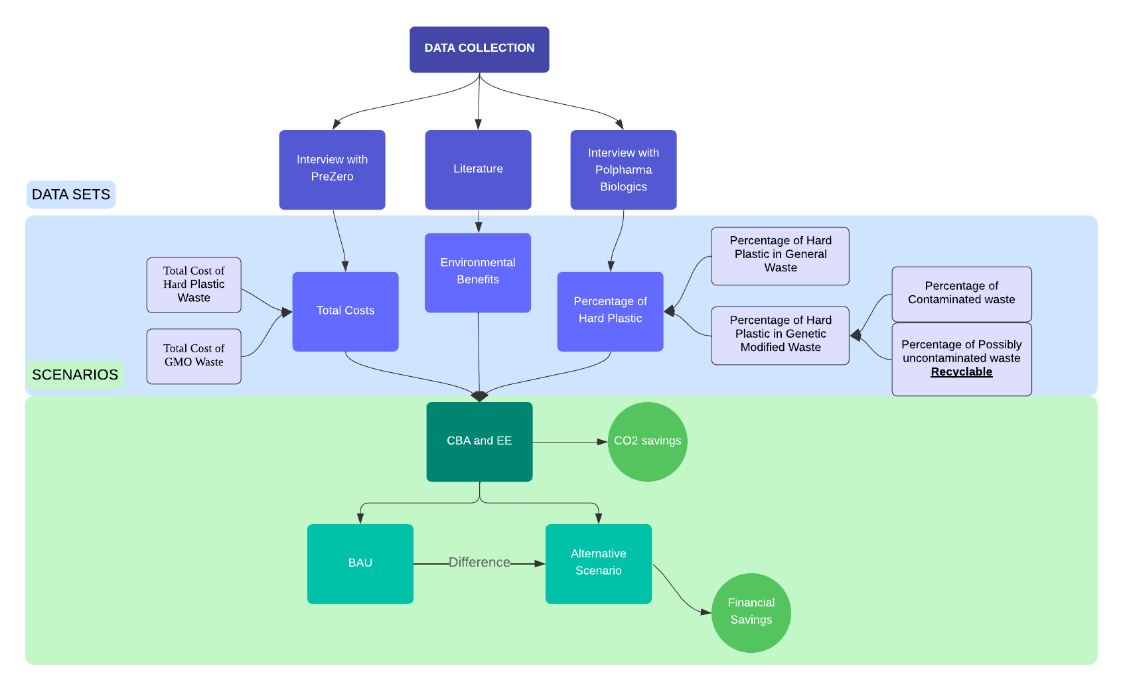
Figure 1. Analytical Framework

Case study selection and Data Collection
To select the case study, an interview with the management of SIU was conducted to decide which startup was eligible to help with the plan. After reaching an agreement with PB, further interviews were planned and conducted to collect important data for calculating each element of the CBA and EE. Furthermore, the company PreZero, which coordinates the collection and recycling of waste was contacted and interviewed to acquire the analytical review of present costs and possible charges that would apply in the alternative scenario proposed.
For collecting data from PB, semi-structured interviews were compiled and carried out in the laboratory environment, focusing on questions about their expenses and waste treatment. Regarding the waste treatment, the investigation centred on how the laboratories operate, the regulations that determine the contamination status of each laboratory or plastic waste, how they are handled in their facilities. and the total waste quantities for a period of a year. Additionally, with the assistance of laboratory workers and based on their experience, generalised assumptions have been made for parameters where data were limited.
The CBA and EE calculations are based on six datasets:
- Percentage of Hard Plastic in General Waste (Transcript of Polpharma interview, 2024)
- Percentage of Hard Plastic in Genetically Modified Waste (Transcript of Polpharma interview, 2024)
  - Percentage of Contaminated Waste (Transcript of Polpharma interview, 2024)
  - Percentage of Possibly Uncontaminated Waste – Recyclable (Transcript of Polpharma interview, 2024)
- Total Cost of Hard Plastic Waste Disposal (see Appendix D)
- Total Cost of GMO Waste Disposal (see Appendix A)
- Percentages of main Hard Plastics in laboratories (Weber et al., 2025)
- Average CO₂ numbers for recycled and fossil plastics in The Netherlands, in kg Carbon Dioxide equivalent (CO₂-eq.) per kg plastic (Delft, C. E., 2023)
Each dataset was defined annually using information derived from the interviews conducted and assumptions regarding stable monthly/yearly amounts of disposed waste (kg) and costs (€/kg). Appendices A-C provide the detailed data.

Analytical Framework

CBA
To quantify the research, CBA is conducted to assess the potential financial savings (in €). This involves accounting for the total costs associated with changing the plastic recycling method by implementing a new waste stream for hard plastics (Alternative Scenario) and comparing it to the costs of the BAU Scenario, with the difference representing the savings potential.
The saving potential was calculated using this formula:
$Saving Potential (€) = Total Waste Cost in BAU (€) - Total Waste Cost in Alternative Scenario (€)$ (1)
$Total Waste Cost of BAU = Total Cost of GMO Waste + Service Fee$ (2)
$Total Waste Cost of Alternative Scenario = Total Cost of GMO Waste + Total Cost of Hard Plastics Waste$
$+ Service Fee$ (3)
The total cost of managing hard plastics and GMO wastes is divided into two main components:
- Investments (I) – These include expenses for purchasing new bins specifically for hard plastic waste.
- Disposal Costs (DC) – These are calculated based on the volume of the waste generated for each type (Hard plastics and GMO) and the associated charges, multiplied by the amount of recyclable plastic within these streams.
The penalties for improper waste separation and the additional time required by laboratory workers to separate plastics are not considered in the monetary calculations. Fixed service fees, as determined through interviews with PB are factored into the overall cost structure.
The costs were calculated using these formula:
$Total Cost of GMO disposal (€)=I + DC of GMO Waste (€/kg) × Recyclable Plastic in GMO Waste (kg)$ (4)
$Total Cost of Hard Plastic Disposal (€) = I + DC of Hard Plastic (€/kg) × Recyclable Plastic in General waste \& GMO Waste (kg)$ (5)

Assumptions made for CBA
- The annual cost and waste weights are based on one week of billing data, assuming four weeks per month and excluding variations caused by holidays or the type of experiments performed
- 50% of the GMO waste is assumed to be contaminated, with 90% of it being hard plastics, based on staff estimates. (see Figure 2, Polpharma Biologics Interview)
- Disposal costs (€150/tonne) are assumed to remain fixed, without accounting market fluctuations or changes in contract terms (see Appendix B and C)
- Laboratory personnel are assumed to be capable of correctly identifying and sorting uncontaminated hard plastics, thereby avoiding misclassification as hazardous waste.
- Hard plastic disposal costs are calculated based on the higher mixed hard plastic processing fee (€150/tonne, see Appendix C). However, there may be other cost-effective alternative measures that were not considered.
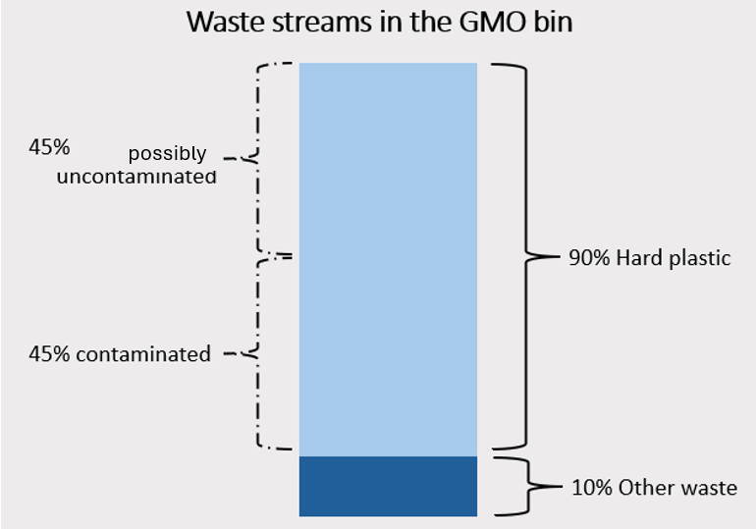

Figure 2. Different types of waste in Polpharma Biologics labs

Environmental Evaluation
For the EE the environmental impact of plastic waste recycling versus fossil-based plastic production was analysed (Figure 3)(Delft, C. E., 2023). Most laboratory items are composed of three types of rigid plastics—polystyrene (PS), polypropylene (PP), and polyethylene (PE)—as well as nitrile, which is commonly used for gloves. A study on laboratory waste revealed that 74% of the waste generated consists of PS and PP, with PS accounting for 42% and PP for 32% (Weber et al., 2025). To calculate this impact, the focus was placed on polypropylene (PP) and polystyrene (PS), the two most commonly used types of hard plastics (Hannay, F., 2002).

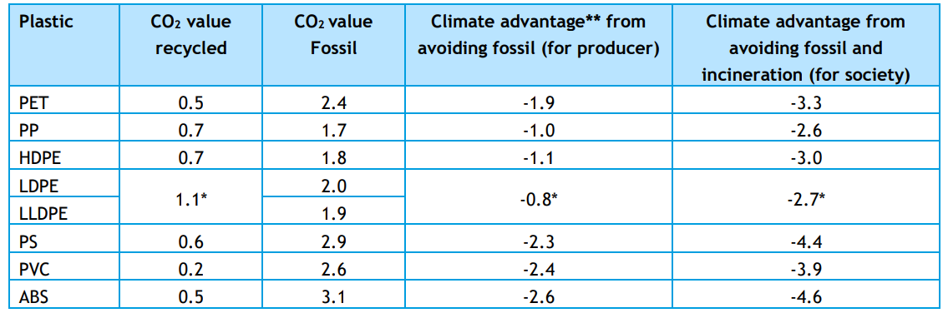

Figure 3. Average CO₂ numbers for recycled and fossil plastics in The Netherlands, in kg CO₂-eq. per kg plastic (Delft, C. E., 2023).
For the calculation of EB, data derived from the interviews with PB (see Appendix A), the percentages of different materials of hard plastic in the waste stream (Weber et al., 2025), and the average CO₂ numbers for recycled and fossil plastics in The Netherlands, expressed in kg CO₂-eq. per kg plastic (Figure 3), was used.
The Environmental Benefits were calculated using these formulae:
$Total Hard Plastic = Hard Plastic from GW + Hard Plastic from GMOW$ (6)
$EB = \% of PP × Total Hard Plastic × Index of CO₂ value$ (7)
$EB = \% of PS × Total Hard Plastic × Index of CO₂ value$ (8)

Results

Interview PreZero
The semi-structured interview with PreZero, the waste management company of the SIU, was useful in providing a better understanding of the different waste streams and their cost structures. However, the cost structure turned out to be more complex than anticipated and depended on a variety of factors. As a result, we only received a rough estimate for the costs of implementing a new hard plastic waste stream.

The key findings from the interview:
- PreZero Services
  - In addition to waste collection, PreZero also offers the service of an on-site Zero Waste Advisor to help minimise residual waste.
  - For a more detailed analysis of the different waste streams, PreZero also offers the service of a waste scan by a specialist.
- Plastic Recycling
  - At the SIU, currently only soft plastics are separated and collected.
  - PreZero offers options for various plastic waste streams , including the collection and recycling of specific hard plastic types, or the inclusion of hard plastics in a combined waste stream.
- General Waste Cost Structure
  - The cost structure of different waste streams generally depends on the following factors: collection distance, strategic structure, contract fee, container type, waste type
  - For a specific waste stream, the cost structure is based either on the volume and substance or on the weight, depending on the waste stream.
- Hard plastic waste cost structure
  - For specific hard plastic types:
    - Pallet box of 660l: rent per box is €5/month, and replacing it when full costs €30. Processing is free.
  - For the mixed hard plastics:
    - Container costs: Around €150/tonne of waste. This is significantly more expensive due to the additional processing and separating fee.

Interview Polpharma Biologics
The semi-structured interview with PB, the startup selected as the case study, helped the team gain deeper insight into laboratory operations. The interview focused on acquiring information about the financial relationship between PB and the SIU concerning the costs of waste disposal, as well as the behavioural stance of laboratory workers towards sustainability initiatives. An on-site inspection of the laboratories revealed some limitations that pose numerous challenges to recycling and waste management plans.

The key findings from the interview are:
- Contamination of waste
  - The general waste bin contains about 30% hard plastics, which consist of large and hollow items like pipet towers. These artefacts can be recycled.
  - Around 90% of the GMO waste is plastic. Glass is often cleaned and reused whenever possible. However, 50% of the plastic that ends up in GMO waste is non-contaminated. This is still disposed of along with GMOs due to the misclassification of non-contaminated plastics as “possibly contaminated” plastics due to regulations.
- Bottlenecks due to waste collection schedule
  - The general waste bin fills up daily and is emptied almost daily. But on occasions, the bin overflows as it is not emptied promptly.
  - In the case of soft plastics, one of the labs uses soft plastic bins effectively. However, other labs lack these dedicated bins, resulting in soft plastics being disposed of in general waste.
- laboratory waste disposal behaviour
  - Paper and cardboard waste is discarded in the wrong bins due to the absence of dedicated bins inside the labs. This leads to lower recycling rates.
  - Labs are willing to adopt additional bins if the waste collection responsibilities are clearly defined.
- Management of expired materials
  - Due to concerns regarding sterility, expired materials are discarded in bulk, which adds to the disposal cost.
  - Occasionally, these items are also given away to other labs.

CBA Results - BAU and Alternative Scenario
The CBA includes the comparison between the baseline scenario (BAU) and the alternative scenario. The analysis shows that the alternative scenario involves a lower annual total cost of €13,320 (see Equation (C.32) in Appendix C) compared to the BAU cost of €14,400 (see Equation (A.13) in Appendix A), resulting in a cost saving of €1,080 (see Equation (C.35) in Appendix C). However, the alternative scenario results in an annual cost of €3,787 (see Equation (C.31) in Appendix C) for hard plastic waste.
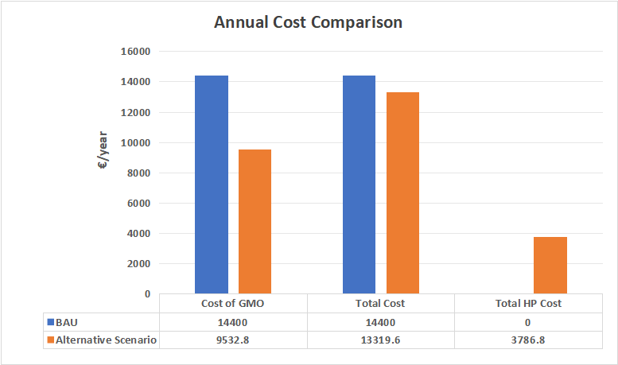

Figure 4. Comparison of Annual Costs Under BAU and Alternative Scenarios (Including GMO and Hard Plastic (HP))

In terms of GMO waste, the alternative scenario annually generates 2,904 kg (see Equation (A.15) in Appendix A), compared to 5,280 kg (see Equation (A.11) in Appendix A) in the BAU scenario. The Alternative Scenario introduces the recovery of Hard Plastic from both GMO and general waste, with Hard Plastic from general waste alone accounting for nearly 23 tonnes of potential recovery. Combined with Hard Plastic from GMO waste, the total Hard Plastic recovery reaches approximately 25 tonnes (see Equation (C.28) in Appendix C), which represents a substantial improvement compared to the BAU scenario, where no hard plastic is recovered.

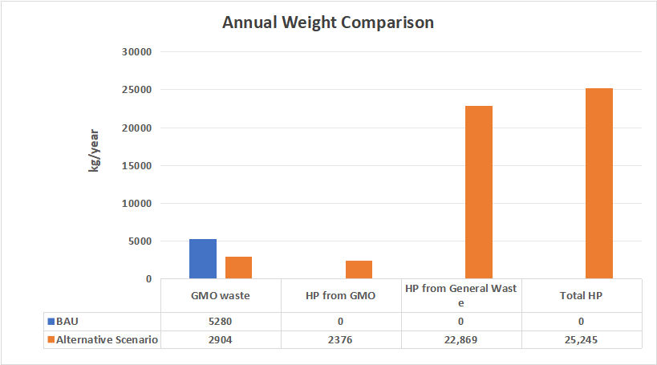

Figure 5. Comparison of Annual Weights Under BAU and Alternative Scenarios (Including GMO and Hard Plastic)

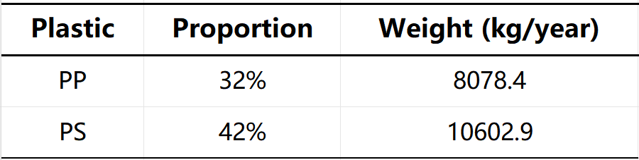

Table 2. Weight of two main types of total hard plastics (Hannay, 2002)

CBA result - Environmental Benefit CO₂
Recycling polypropylene (PP) results in 5.7 tCO₂-eq. emissions, which is approximately 50% lower than the 13.7 tCO₂-eq. emissions generated by fossil-based production, providing a climate benefit of 8.1 tCO₂-eq. When both fossil-based production and incineration emissions are avoided, the climate benefit increases further to 21 tCO₂-eq.

Similarly, recycling polystyrene (PS) generates 6.4 tCO₂-eq. emissions, compared to 30.7 tCO₂-eq. emissions from virgin production. This represents a climate advantage of 24.4 tCO₂-eq. The inclusion of incineration emissions further increases the climate benefit to 46.7 tCO₂-eq.

Plastic Material Type | CO₂ value recycled  (tCO₂-eq.) | CO₂ value Fossil  (tCO₂-eq.) | Climate advantage from avoiding fossil (for producer) (tCO₂-eq.) | Climate advantage from avoiding fossil and incineration (tCO₂-eq.)
PP | 5.7 | 13.7 | -8.1 | -21.0
PS | 6.4 | 30.7 | -24.4 | -46.7
Total | 12.0 | 44.5 | -32.5 | -67.7

Table 3. Environmental benefits of recycling polypropylene (PP) and polystyrene (PS) compared to fossil-based production

Discussion

Cost Savings and Financial Considerations
Our findings suggest that PB could achieve annual cost savings of up to €1,268 by separating hard plastics from the GMO and commercial waste streams and diverting them to a dedicated hard plastic waste stream (see figure 3). While this amount may appear modest, it holds value for a start-up operating under financial constraints. This figure accounts for reductions in GMO waste costs and the added costs associated with a hard plastic waste stream.
However, several limitations affect the reliability and validity of these results. The financial estimate excludes potential savings from separating hard plastics from commercial waste due to SIU’s waste cost structure, where commercial waste costs are fixed and included in rent. This restricted our ability to account for the savings from reduced commercial waste. Additionally, the cost estimate for a hard plastic waste stream is based on an interview with PreZero, which acknowledged variability in pricing based on external factors (see Appendix D-1). The GMO waste cost was similarly derived from a single weekly invoice provided by Polpharma Biologics during our interview, as further financial data was unavailable due to confidentiality.
A more thorough investigation of waste stream quantities over an extended time horizon would provide more reliable data. For instance, a monthly waste scan by PreZero could yield accurate estimates of waste composition, enabling a more robust CBA. Furthermore, the financial impact of a new hard plastic waste stream depends on how SIU structures its costs – whether as a fixed component of rent or as a direct expense billed to individual companies.
To address these challenges, we recommend SIU implement a waste cost structure that balances operational feasibility with sustainability goals. Adjusting rent to reflect hard plastic waste stream costs while offering companies financial incentives to separate hard plastics could encourage better waste management practices. Behavioral interventions, such as workshops, improved signage, and accessible hard plastic bins near laboratory workstations, could further promote waste segregation and increase the reliability of these savings estimates.

Environmental Benefits
The environmental impact of separating hard plastics is substantial, as our results indicate a potential diversion of 25 tons of hard plastics annually—18.5 tons of which consist of PP and PS. Recycling this material could reduce greenhouse gas emissions by approximately 67.7 tCO₂-eq. annually, through the avoidance of virgin plastic production and incineration (see Table 3). These results emphasize the substantial sustainability benefits of implementing a hard plastic waste stream.
However, several factors limit the validity and broader applicability of these findings. The classification of ML-I and ML-II laboratories, for example, presents a major barrier to hard plastic recycling. Strict protocols require most materials used in these laboratories to be treated as contaminated, even when contamination is unlikely. This limits the recycling potential of laboratory-derived hard plastics, which could otherwise significantly contribute to the hard plastic waste stream.
Moreover, our findings are derived from a single case study at Polpharma Biologics and are based on limited data availability. While they offer valuable insights, their generalisability to other start-ups or research facilities within SIU or beyond remains uncertain. The lack of comparable literature or research on hard plastic waste separation in laboratories further restricts the ability to validate our results against broader industry benchmarks. Future studies should aim to address this gap by examining hard plastic waste management in diverse settings and over longer time horizons.
The time horizon of our research represents another limitation. Short-term observations and interviews informed our estimates, which may not fully capture the variability in waste generation or disposal practices over time. Long-term studies, including regular waste audits and scans, would improve the reliability of the data and provide a clearer picture of the cost savings and environmental benefits associated with a hard plastic waste stream.

Conclusion and Recommendations
This report investigated the following research question:
To what extent can PB reduce financial costs and increase environmental benefits by introducing targeted interventions for hard plastic waste segregation in laboratories?
To answer the question, a CBA has been performed on the BAU and the alternative scenario involves the introduction of a hard plastic bin. The results display differences in the overall annual costs and weights of the GMO, general and the new hard plastic bin. Furthermore, the CO₂ equivalent emissions highlight the environmental benefit of the alternative scenario compared to the BAU scenario.
The introduction of a hard plastic bin in the labs could result in annual cost savings of €1,268 and a reduction in greenhouse gas emissions of 66.7 tCO₂-eq. Therefore, Polpharma Biologics can reduce financial costs and increase environmental benefits by targeted interventions such as the introduction of extra bins for hard plastic waste segregation in laboratories.
This leads to the following recommendations:
- It is recommended that PB implement an additional waste bin in laboratory areas specifically designated for the collection of hard plastics. This initiative would facilitate the segregation of hard plastic materials that, under the current Business-As-Usual (BAU) scenario, are disposed of in the general waste stream. By capturing these materials separately, the company can enhance waste diversion efforts and contribute to improved environmental sustainability.
- Additionally, it is advised that PB conduct a comprehensive review of laboratory regulations to precisely determine which waste items are permitted by regulatory standards to be excluded from the GMO-designated waste stream. This assessment would enable the identification of additional materials suitable for recycling, thereby optimizing waste management practices and potentially achieving further cost reductions.
Both PP and PS show considerable benefits in terms of reducing CO₂ emissions when recycled, particularly in the context of avoiding fossil-based production processes. And, the difference in annual costs can make a notable impact for a start-up operating with limited financial resources.

References
Alves, J., Sargison, F. A., Stawarz, H., Fox, W. B., Huete, S. G., Hassan, A., McTeir, B., & Pickering, A. C. (2020). A case report: insights into reducing plastic waste in a microbiology laboratory. Access Microbiology, 3(3), 000173. https://doi.org/10.1099/acmi.0.000173

AMT Medical. (n.d.). Retrieved from https://amt-medical.nl/

Brunner, P. H., & Rechberger, H. (2004). Practical handbook of material flow analysis. The International Journal of Life Cycle Assessment, 9(5), 337–338. https://doi.org/10.1007/BF02979426

Chemical Waste Netherlands. (n.d.). Chemical waste legislation in the Netherlands. Retrieved from https://chemischafvalnederland.nl/en/chemical-waste-legislation/

Delft, C. E. (2023). CO₂-winst met kunststofrecyclaat. Een overzicht van CO2-kentallen van mechanisch kunststofrecyclaat voor NRK Recycling.

Eriksen, M. K., Christiansen, J. D., Daugaard, A. E., & Astrup, T. F. (2019). Closing the loop for PET, PE and PP waste from households: Influence of material properties and product design for plastic recycling. Waste Management, 96, 75–85. https://doi.org/10.1016/j.wasman.2019.07.005

GenDx. (n.d.). Retrieved from https://www.gendx.com/

Geyer, B., Lorenz, G., & Kandelbauer, A. (2016). Recycling of poly(ethylene terephthalate) – A review focusing on chemical methods. Express Polymer Letters, 10(7), 559–586. https://doi.org/10.3144/expresspolymlett.2016.53

Gyes. (n.d.). Retrieved from https://gyes.com/

Hannay, F. (2002). Rigid Plastics Packaging: Materials, Processes and Applications. iSmithers Rapra Publishing.
Kimman, T. G., Smit, E., & Klein, M. R. (2008). Evidence-based biosafety: a review of the principles and effectiveness of microbiological containment measures. Clinical microbiology reviews, 21(3), 403–425. https://doi.org/10.1128/CMR.00014-08

Hub Organoids. (n.d.). Retrieved from https://www.huborganoids.nl/

Huysman, S., Debaveye, S., Schaubroeck, T., De Meester, S., Ardente, F., Mathieux, F., & Dewulf, J. (2015). The recyclability benefit rate of closed-loop and open-loop systems: A case study on plastic recycling in Flanders. Resources, Conservation and Recycling, 101, 53–60. https://doi.org/10.1016/j.resconrec.2015.05.014

Labshop. (2024, 31 oktober). Reageerbuisrek voor Ø25 mm - 40 Buizen - Labshop. https://www.labshop.nl/reageerbuisrek-voor-25-mm-40-buizen-wit/?attribute_pa_kleur=blauw?utm_source=google-surfaces&utm_medium=organic&gad_source=1&gclid=Cj0KCQiAs5i8BhDmARIsAGE4xHwC0TDVWgq0PtCsr8-wPcX3vIizqkSeC0ykARTWFLe1cca9Fuw9vbYaAnkuEALw_wcB
Laigo Bio. (n.d.). Retrieved from https://www.laigobio.com/en/

Lava Therapeutics. (n.d.). Retrieved from https://www.lavatherapeutics.com/

Lazarevic, D., Aoustin, E., Buclet, N., & Brandt, N. (2010). Plastic waste management in the context of a European recycling society: Comparing results and uncertainties in a life cycle perspective. Resources, Conservation and Recycling, 55(2). https://doi.org/10.1016/j.resconrec.2010.09.014

Macheca, A. D., Mutuma, B., Adalima, J. L., Midheme, E., Lúcas, L. H. M., Ochanda, V. K., & Mhlanga, S. D. (2024). Perspectives on plastic waste management: Challenges and possible solutions to ensure its sustainable use. Recycling, 9(5), 77. https://doi.org/10.3390/recycling9050077

Moriguchi, Y., & Hashimoto, S. (2014). Material Flow Analysis and Waste Management. In Taking Stock of Industrial Ecology (pp. 247–262). Springer. https://doi.org/10.1007/978-3-319-20571-7_12

National Research Council. (2009). Prudent practices in the laboratory: Handling and management of chemical hazards. Washington, DC: The National Academies Press. Retrieved from https://nap.nationalacademies.org/read/12654/chapter/9

Polpharma. (n.d.). Retrieved from https://polpharma.pl/en/

PreZero International. (n.d.). Retrieved from https://prezero-international.com/en/about-us

Reageerbuiswinkel. (2024, 12 december). Reageerbuisrek | wit | Autoclaveerbaar - Reageerbuiswinkel. https://reageerbuiswinkel.nl/product/reageerbuis-rek-wit-autoclaveerbaar/

Solvias. (n.d.). Retrieved from https://www.solvias.com/
SP Bel-Art Pipette Support Rack, 16mm, 50 Places, 8-3/8" x 4-1/2" x 8-3/4", Polypropylene. (z.d.). Core & Main. https://supply.coreandmain.com/SP-Bel-Art-Pipette-Support-Rack-16mm-50-Places-8-3-8-x-4-1-2-x-8-3-4-Polypropylene?srsltid=AfmBOorY3FJguVPjFfFaVRbC_pVtK97vcPyt6J6t--lXRo-rDDzj6vVF

Thuja Capital. (n.d.). Retrieved from https://www.thujacapital.com/

Torkashvand, J., Emamjomeh, M. M., Gholami, M., & Farzadkia, M. (2021). Analysis of cost–benefit in life-cycle of plastic solid waste: combining waste flow analysis and life cycle cost as a decision support tool to the selection of optimum scenario. Environment, Development and Sustainability, 23, 13242–13260. https://doi.org/10.1007/s10668-020-01208-9

UCYTech. (n.d.). Retrieved from https://www.ucytech.com/

UMC Utrecht Medical Physiology. (n.d.). Retrieved from https://www.umcutrecht.nl/nl/medphysiol

Wamba, S. F., Fotso, M., Mosconi, E., & Chai, J. (2023). Assessing the potential of plastic waste management in the circular economy: A longitudinal case study in an emerging economy. Annals of Operations Research. https://doi.org/10.1007/s10479-023-05386-3

Weber, P. M., Michelsen, C., & Kerou, M. (2025). What’s in our bin? EMBO Reports, 1–6. https://doi.org/10.1038/s44319-024-00360-x

Appendix

Appendix A: GMO Waste Disposal Costs in PB laboratory
Basis of Calculation: First Interview with Polpharma (Transcript)
Regarding GMO waste: It’s a variable price based on the amount of bins and the weight. (€6/bin fixed). Last week there were 17 GMO bins and it weighed 110 kg in total (€1200/ton). The total price last week was around €300 which includes the amount of bins, the weight and a service fee.
GMO Waste Cost Structure:
- Fixed Cost per Bin: €6/bin
- Cost per Ton of Waste: €1200/ton
- Service Fee: €66
Thus, the total cost per week for disposing of GMO waste based on an average of 110 kg per week is calculated as follows:
BAU cost of GMO waste:
- GMO Waste Fixed Cost:
$66 (€) × 12 (months/year) × 4 (weeks/month)=3168(€)$ (9)
- GMO Waste Processing Cost:
$816 (bins)×6 (€/bin)=4896(€)$ (10)
- Annual GMO Waste Weight:
$110 (kg) × 12 (months/year) × 4 (weeks/month)=5280(kg)$ (11)
- General GMO Waste Processing Cost:
$5.280(tonne) × 1200 (€/tonne)=6336(€)$ (12)
- Total BAU Cost:
$3168 (€)+4896 (€)+6336 (€)=14400 (€/year)$ (13)
CBA Alternative cost of GMO waste:
- Hard Plastic from GMO waste:
$110 (kg/week) × 45\%=49.5 (kg hard plastic/week)$ (14)
- Remaining non-hard plastic waste:
$110 (kg/week)−49.5 kg=60.5 (kg of other waste/week)$ (15)
- Annual GMO Waste Weight:
$60.5 (kg) × 12 (months/year) × 4 (weeks/month)=2904(kg)$ (16)
- The number of bins used for hard plastic:
$17 (bins) / 110 (kg) × 60.5 (kg)=9.35 ≈ 10 (hard plastic bins)$ (17)
- GMO Waste Disposal Cost per Week:
$Cost of GMO waste=10 (bins) × 6 (€/bin)+(60.5 (kg)×1/1000 (t/kg)×1200 (€/t)+66 €$
$=198.6 (€/week)$ (18)
- Annual GMO Waste Disposal Cost:
$Annual cost of GMO=198.6 (€/week) × 4 (weeks/month) ×12 (months)=9532.8 (€/year)$ (19)

Appendix B: Data related to hard plastic in general waste bin in a laboratory in PB
Bin specifications:
- Capacity: 60 L
- Height: 46 cm, Width: 32 cm
$Height used for hard plastic = 30\% × 60 L = 17.4 cm$ (20)
Three different pipette racks
- Rack 1 (SP Bel-Art Pipette Support Rack, 16mm, 50 Places, 8-3/8" X 4-1/2" X 8-3/4", Polypropylene, n.d.):
  - Weight: 552.84 grams
  - Dimensions: 8.375 cm × 4.5 cm × 8.75 cm
- Rack 2 (Labshop, 2024):
  - Weight: 340 grams
  - Dimensions: 260 mm × 130 mm × 60 mm
- Rack 3 (Reageerbuiswinkel, 2024):
  - Weight: 130 grams
  - Dimensions: 250 mm × 100 mm × 70 mm
Average dimension rack:
$Length =(8.375+26+25)/3=19.79 cm$ (21)
$Width = (4.5+13+10)=9.17 cm$ (22)
$Height =(8.75+60+70)/3=7.25 cm$ (23)
Average weight rack:
$(130 (g) + 340 (g) + 552.84( g)) / 3 = 340.94 (g)$ (24)
Total number of labs and bins:
- Assume there are 10 labs, each with 2 general waste bins:
$10 labs × 2 bins = 20 bins$ (26)
Each bin is full every day, there are 100 bins per week:
$100 (bins/week) × 48 (weeks) = 4800 bins/year$ (27)
Hard plastic amount in each bin:
$14 (racks) × 340.94 (g/rack) = 4.77 (kg)$ (25)
Annual total weight of hard plastics from general waste:
- The total annual weight of hard plastics is:
$4800 (bins/year) × 4.77 (kg) = 22,869 kg/year$ (28)

Appendix C: Net cost benefit
Mixed Hard Plastic Cost Structure:
The cost for mixed plastics disposal is approximately 150 € per 1000 kg, which includes both the rent for the containers and the processing/separation fees.
- Annual GMO Waste Disposal Cost:
$Annual cost of GMO=198.6 (€/week) × 4 (weeks/month) ×12 (months)=9532.8 (€/year)$ (29)
- Annual Hard Plastic Waste Disposal Cost:
$49.5 (kg/week) × 4 (weeks/month)× 12 (months/year)=2976 (kg/year)$ (30)
$(22,869+2376) (kg/year) × 150 (€/tonne)=3786.75 (€/year)$ (31)
- Total Alternative Disposal Cost:
$9532.8 (€/year) + 3786.75 (€/year)=13319.6 (€/year)$ (32)
- Total Hard Plastic Weight:
$2976 (kg/year)+ 22,869 kg/year=25845 (kg/year)$ (33)
- Savings:
$Savings=BAU Total Cost−Alternative Total Cost$ (34)
$Savings=14400 (€/year) - 13319.6 (€/year)=1080.4 (€/year)$ (35)

Appendix D-1: Transcript of the Interview with PreZero
Date: 12-12-2024
Q= Questions from the student consultancy team
T= Tim ten Velde (Accountmanager at PreZero)

Q1: What is PreZero’s mission?
T: Our goal is to minimise residual waste and to provide other waste streams that can be recycled.

Q2: What kind of services does PreZero offer?
T: At PreZero we offer different kinds of services. Our main service is of course the collection of different waste streams. Here at the SIU we collect all the different waste streams, ranging from residual waste, glass and cardboard to plastic and GMO waste.
Besides this, we also offer the following useful services:
- Zero Waste Advisor for minimizing residual waste,
- Waste scan on location by a specialist to analyze the content of various waste streams.

Q3: Regarding plastics, which types do you differentiate?
T: Here at the SIU there is currently only a waste stream for soft plastic separation. But of course we also offer waste streams for hard plastics. This can either be one waste stream for all hard plastics combined, or for a specific hard plastic type.

Q4: What is the general cost structure?
T: It depends on a lot of factors, such as distance of collection, strategic structure and more. But generally, the volume and substance calculates the cost of the waste. Then there are also different costs associated with the type of container for the waste collection: There are normal containers for the majority of waste streams and also semi-underground containers and press containers for certain waste streams. For the latter two, the cost is determined on how often they have to be emptied, for the container the weight is the determining factor. Then there is also a contract fee which depends if it’s a new contract or if it is simply a new waste stream that can be added to already existing contracts for other waste streams.

Q5: What is the cost and pricing structure for different plastic types?
T: It depends on the plastics type. Combined plastics are difficult to separate, therefore the waste stream for combined hard plastics is a lot more expensive than for a single hard plastic waste stream.
The cost structure for a single hard plastic waste stream is as follows:
- Pallet box of 660l for a specific plastic stream: rent per box is 5 Euros / month, replacing it is 30 Euros. The processing is free, but there is an additional residual waste cost, usually around 1.70-1.90 Euros per 1000 kg.
- For the mixed hard plastics the structure is different: It’s a container that costs around 150 Euros per 1000 kg waste. It’s a lot more expensive as there is an additional processing / separating fee.
On top of that there would also be costs for purchasing the bins for the labs to start the separation process there.

Q6: What is the process to create a new waste stream?
T: The client can send us photos of the product and we can then determine if it’s recyclable and we offer the corresponding waste stream. If we know the quantity of total hard plastics and that of a specific hard plastic we can determine if it makes more sense to have a combined or specific hard plastic waste stream.

Appendix D-2: Transcript of the Interview with Polpharma Biologics (1)
Date: 18-12-2024
K= Klaas Stienstra (Polpharma Biologics Laboratory Manager)
R= Rosita Paleckyte (Polpharma Biologics Scientific Laboratory worker)
- Disposal Cost
  - How much do you currently have to pay the SIU for commercial waste?
    - What is the waste contract?
K: I don’t know exactly. The cost is included in the rent
K/R: At SIU there are a lot of cell-based companies that produce mostly waste with GMO status in the labs. There are special bins for GMO with a separate waste contract. In our laboratory almost everything has GMO status.
    - Is it a fixed or variable price?
K: Regarding GMO waste: It’s a variable price based on the amount of bins and the weight. (6€ per bin fixed). Last week there were 17 GMO bins and it weighed 110 kg in total (1200.- /t). The total price last week was around 300€ which includes the amount of bins, the weight and a service fee.
=> GMO waste price structure: 17*6€ + 0.11t*1200€/t + service fee.
Generally: [Amount of bins] * 6€ + [Weight of waste in t] *1200€/t + service fee.
K: Most things in the labs have a GMO status, even though there is none. There are special bins for GMO waste. A lot of cell based companies. A lot of this type wastes at SIU.
    - And for soft plastic recycling? Is it included in the rent?
K: Yes, soft plastic is included in the rent. Soft plastics and styrofoam are also already separated. As well normal waste, cardboard, and green, glass and paper. This is all included in the rent.

- What is the input of plastic products/materials?
  - What are the categories (Different types of plastics / polymers) with the largest proportions?
K/R: It’s based on the function of the product, but the most important thing is that it’s non-reactive with chemicals. There is not a large choice and PP is most widely used. Mostly it is the same manufacturer and we have deals with certain. We’re also considering the price of course.
  - Do you purchase materials for all labs together or separately?
    - What would be the biggest challenge in purchasing together, considering we can avoid a lot of packaging waste? Would you be willing to accept such a change?
K/R: Could be a good idea, also to get deals together with other labs for ordering in bulk. Indeed, the problem is the lack of independence for ordering products more spontaneously.
  - How much stock of supplies (in terms of time to empty) do you keep?
    - Are there any products that have expiry dates? (Either apparatus made of plastics, or other supplies that come in plastic packaging)
K/R: We have only very limited stock capacity. Usually we only order what we need for the coming months. And yes, there are expiry dates for certain products.

- What is the outflow of plastic products/materials
- How rigorously are uncontaminated and contaminated products separated?
R: There is a spectrum for contamination: potentially having GMOs - ML1 or ML2 status which affects the possibility to dispose of trash, as it is potentially contaminated.
R: Common sense is not allowed to be used, as the standards must be followed. Our hands are tied - limited possibilities as the majority of contaminated waste are not actually contaminated but possibly contaminated. Basically, this results that there is no uncontaminated plastic waste from the labs (except before usage, such as packaging waste, or paper).
  - Differentiation of plastic polymers
    - Are there signs / labels on each single plastic product to determine the type of plastic and help differentiate? Or is it only on the packaging/box it comes in? For pipettes for example.
R: It is not really relevant for us. There are other steps needed to decontaminate the waste before it could be separated. For a start-up it’s a big burden - we don’t have the capacity.
Q: If SIU would provide a decontamination service for all labs together - would this be a possibility?
R: Not really. There would be a lack of trust if it’s washed multiple times that it could affect results.
- Commitment to sustainability
  - Do you have any specific sustainability commitments?
R: We use the tower for pipettes which we can reuse and also its an advantage space-wise. We try to use vendors that offer promotions with new products using less packaging. We also noticed that there are vendors which use more plastic which we try to avoid as it is not only unsustainable but also inconvenient to unwrap. In general, if it doesn’t incur additional costs or effort there is definitely a willingness to improve negative environmental effects.
  - Do you adopt any circular economy R-strategies (below) for the materials (and plastic materials in particular) you are using?
K/R: We try to start at an earlier stage of the R: reduce products. We currently use a lot of single-use plastics.

- Switching to alternative material
  - Are you considering alternatives (such as glass) to switch from single-use plastics?
R: There are environmental and financial incentives. In some cases we already implemented glass usage for tubes and then cleaning it in the dishwasher. But the problem is non-sterility if we want to use it for our experiments.

- Behavioural questions
  - During your lab-work hours, how do you manage your plastic waste?
R: There is a lack of clarity of plastic separation. A couple of years ago a hard plastic bin was already tried, but it was not very clearly instructed what went where. Now we just use the rule of thumb that if the plastic crumbles in our hand then it is soft plastic. Would you be willing to make an extra effort, spend extra time on waste separation?
    - What can be an efficient waste disposal schedule (Monday to Friday or End of the week) based on our scenario? Is someone willing to be in charge to make sure of proper waste separation?
R: We would need a service to pick up trash bins from the labs and bring them down. It’s labor and not so easy. If I have to bring down the soft plastic container it’s often quite full with bulky products. We don’t have the capacity!
    - Would you consider differentiating PE additionally once a week if there was an extra bin for it?
R: We would need clear specification from Cora / PreZero of which individual plastic products can be put into which trash stream.

- Practical questions
  - Can we go through your general waste and plastic uncontaminated bins three times in January? (day before pick up)
R: It should be possible.
Further notes comments:
K/R: Electric waste can’t be disposed of at the SIU (for light bulbs for example). Now we store it and sometimes take it home to dispose of correctly. Now it’s once a year that Cora organises this, until then it is otherwise stored in the labs, but there is limited space. Would be helpful to have this more regularly.

Appendix D-3: Transcript of the Interview with Polpharma Biologics (2)
Date: 10-01-2025
K= Klaas Stienstra (Polpharma Biologics Laboratory Manager)
R= Rosita Paleckyte (Polpharma Biologics Scientific Laboratory worker)
Regarding ML-I and ML-II labs, regulations result in artefacts being labelled as "possibly contaminated" and, as a result, cannot be recycled, correct? Yes.
Also, correct that in the lab, there is a general waste bin and a contaminated GMO bin? Yes.
What kind of products end up in the general waste bin?
Hard plastics, paper, cartons, gloves, etc. Soft plastic and soft plastic packaging are thrown away in the common area in the orange bin. We don’t have a paper bin in the lab, so when people don’t bother going out of the lab, it ends up in the general waste bin.
How often is the general waste bin in the labs emptied?
The cleaners do it, but sometimes they don’t, or they only empty one bin. The bins are full after just one day.
Can you estimate what percentage in the general waste bin is hard plastic?
About 30%, but most hard plastic items are large, like the pipet tower. It’s large but hollow.
Okay, so is the 30% more in terms of weight or the volume of the bin?
It’s more in terms of volume, so 3/10 of the bin is hard plastic.
Klaas and Rosita discussed the "bottle top filter," which goes in the contaminated bin because someone told Rosita to do so, but she is very sure it is rarely actually contaminated.
Rosita added that technically, her laboratory does not have GMOs.
How much plastic is in the GMO bin?
A lot, about 90%. The glass is washed, so almost all the waste is plastic.
And how much of that is probably not contaminated?
About 50% of it. A lot of it is just filled with water.
It was mentioned that soft plastic is all recycled in the common area. In Rosita’s lab, they have a bin for soft plastic, which they take out to a larger bin in the common area. The one in the common area is a large Kliko bin.
How often is the soft plastic bin taken down?
Emma used to do it once every month, but it was always extremely full, pressed together to fit more.
So soft plastic is your responsibility?
Yes, because we needed an extra one, and Cora said that was fine as long as we took it down ourselves. But nobody does that, except Emma (who is gone now).
Do you think that placing a hard plastic bin next to the soft plastic bin in the laboratory would work behavior-wise?
Yes, it would work as long as it is clear and someone takes it down.
How many labs do you have? And how many bins?
The 6th floor has four labs, of which three have one bin each, and one laboratory has two general waste bins and one GMO bin. The 2nd floor has six labs, with two bins of each type in each lab.
There was a discussion about expired items, which includes a lot of hard plastic as well.
How often/how many expired items/leftovers are thrown away?
Two times a year, there is a big cleanup, and a pallet up to one meter high is collected. However, the plastic is in cardboard boxes. Before throwing it away, we ask other labs in SIU if they want anything.
Does that also go the other way around?
Yes, other labs do that too.
How does plastic expire?
The sterility is guaranteed for three years. After that, you can’t be sure whether an experiment went a certain way because of what you did or because of the potential loss of sterility. For example, bioreactors splinter.
Bottles and cans are collected, such as sparkling water bottles. Paper and carton need to be thrown away outside the lab.
Why do you not have the same system for carton/paper, like a temporary bin in the laboratory that gets emptied into the common area?
I don’t know. We should look at that or think about it.
Tour Observations:
Rosita’s laboratory has a soft plastic temporary bin that is taken to the common area. The laboratory observed downstairs did not, and the general waste bin contained five items at that moment, four of which were soft plastic packaging.
Klaas commented that he doesn’t believe they take soft plastic out of the lab very often.
Tour Storage Closet:
They have new pipet racks containing less material and therefore are more sustainable, though slightly less stable. The less-material rack has a recycle logo 1 (PETE), while the normal racks in the PB lab have a recycle logo 5 (PP).
While looking at an expired box, it was noted that it was a cardboard box with hard plastic boxes inside, wrapped in soft plastic. Klaas explained that this goes into the underground general waste bin because otherwise, somebody would have to unwrap it all.
Klaas mentioned that in the new labs in the other building, there will be central spaces for bins within the labs, which will make it much easier to manage waste.
When asked if it would be possible to place separate bins for soft plastic, hard plastic, and paper, Klaas said he had not looked into it but agreed that it would be feasible.

